TERRAFORM

Terraform- Terraform is an open-source infrastructure as a code (IAC) tool that allows to create, manage & deploy the production-ready environment. Terraform codifies cloud APIs into declarative configuration files. Terraform can manage both existing service providers and custom in-house solutions.

Create a ec2 with amazon linux server and security group as ssh and keypair.

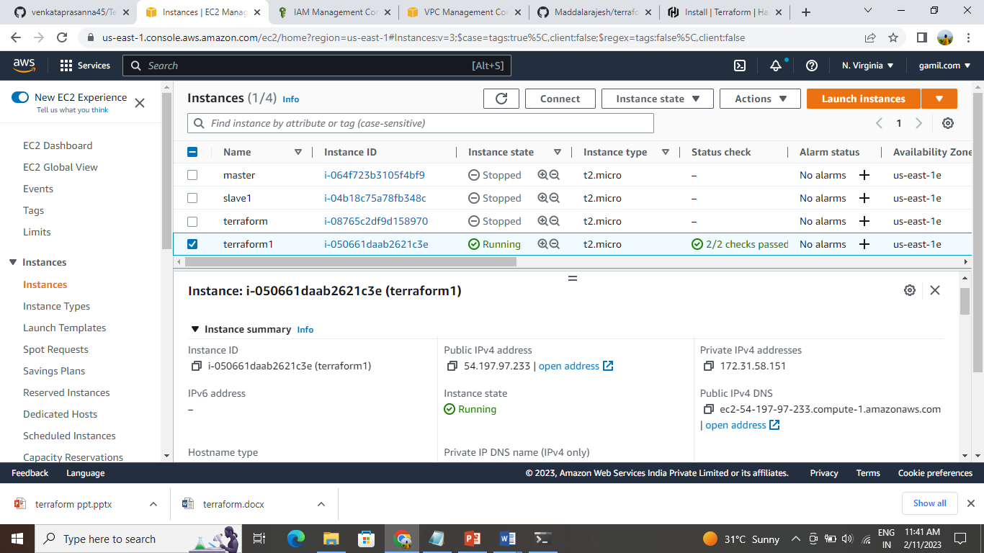

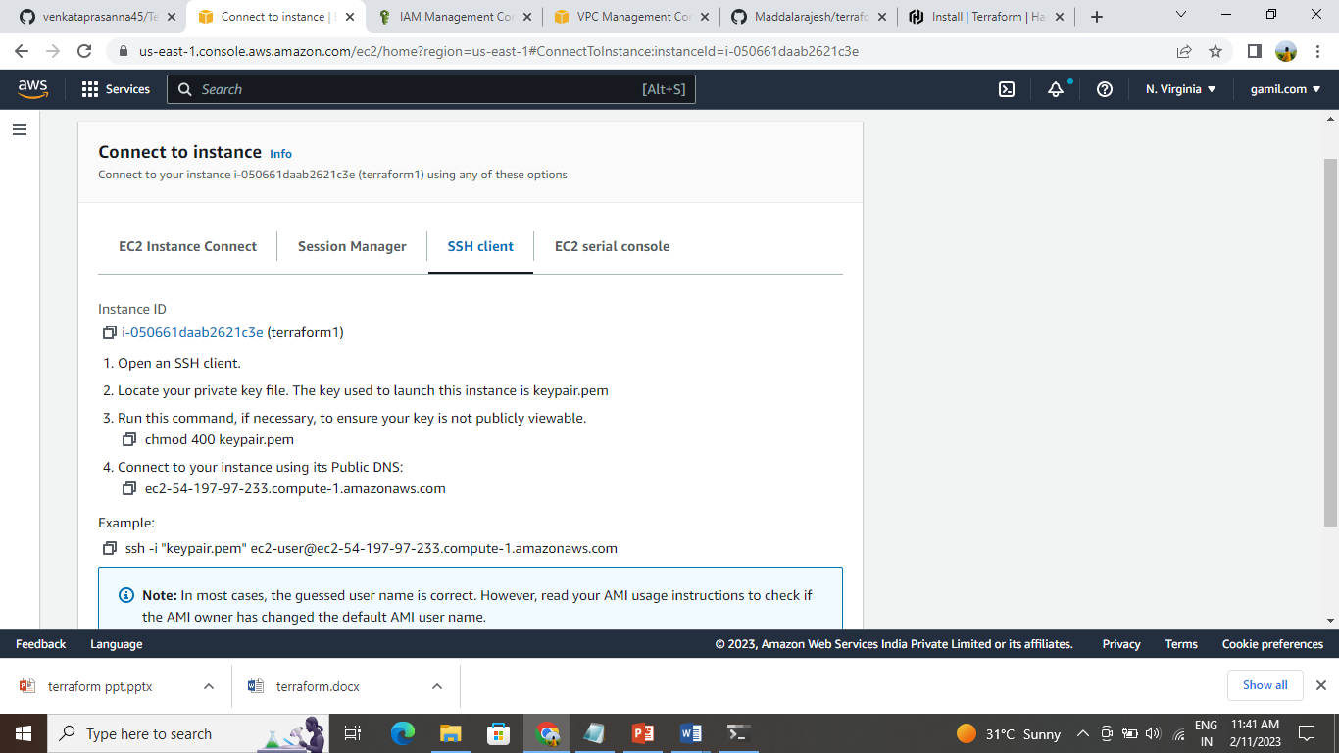

And the instance is connected to terminal.

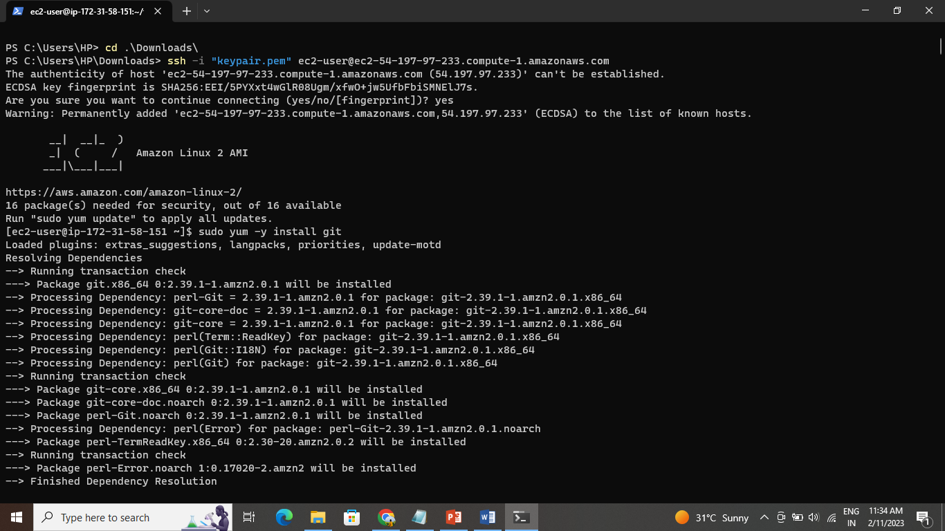

Update the server-and install the terraform and install the packages

sudo yum install -y yum-utils shadow-utils

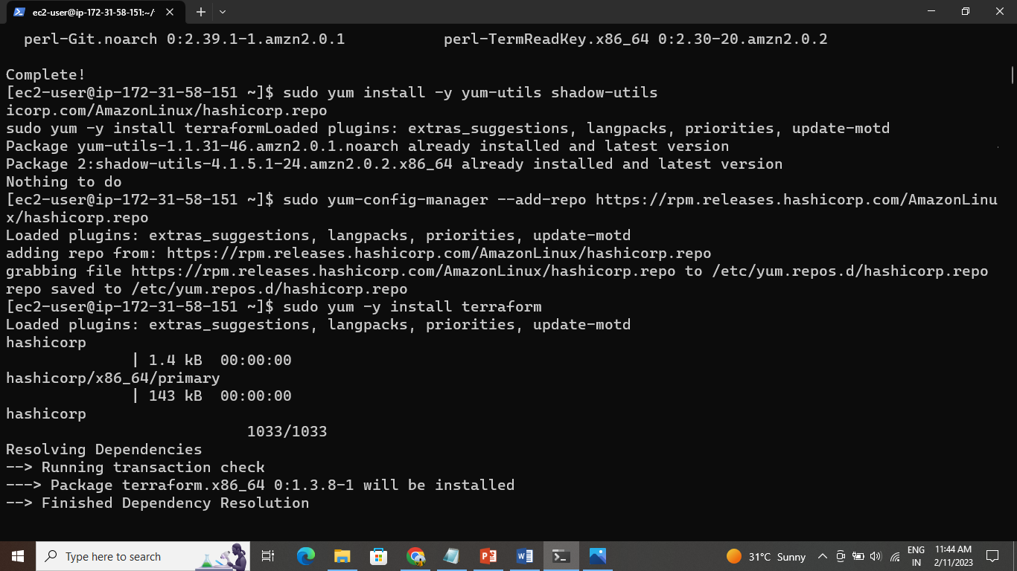

sudo yum-config-manager --add-repo https://rpm.releases.hashicorp.com/AmazonLinux/hashicorp.repo

Sudo yum –y install terraform  
  
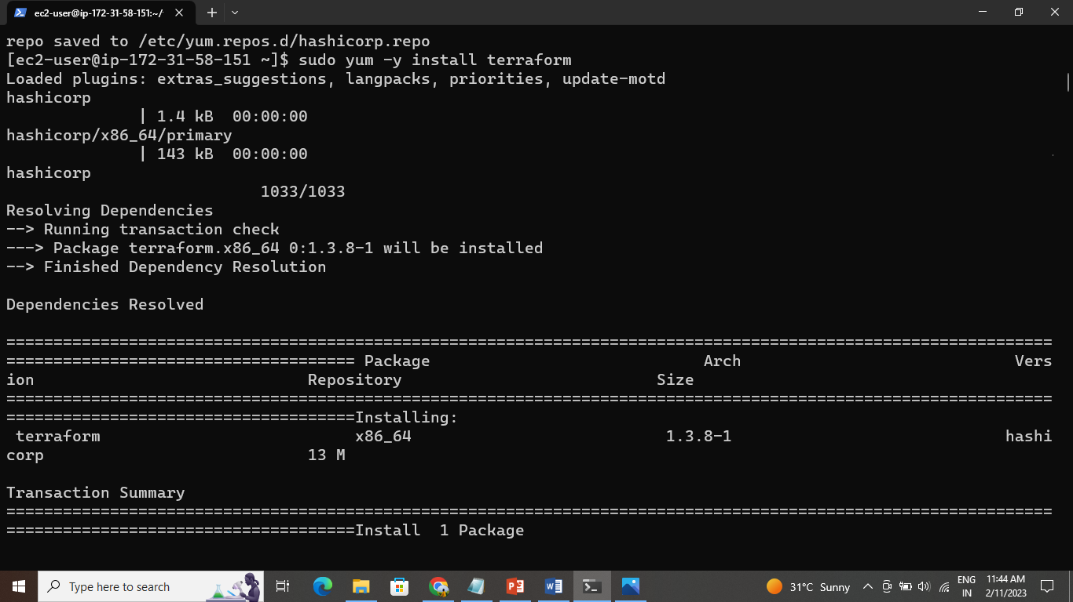

And make a directory by using the command

Mkdir terraform

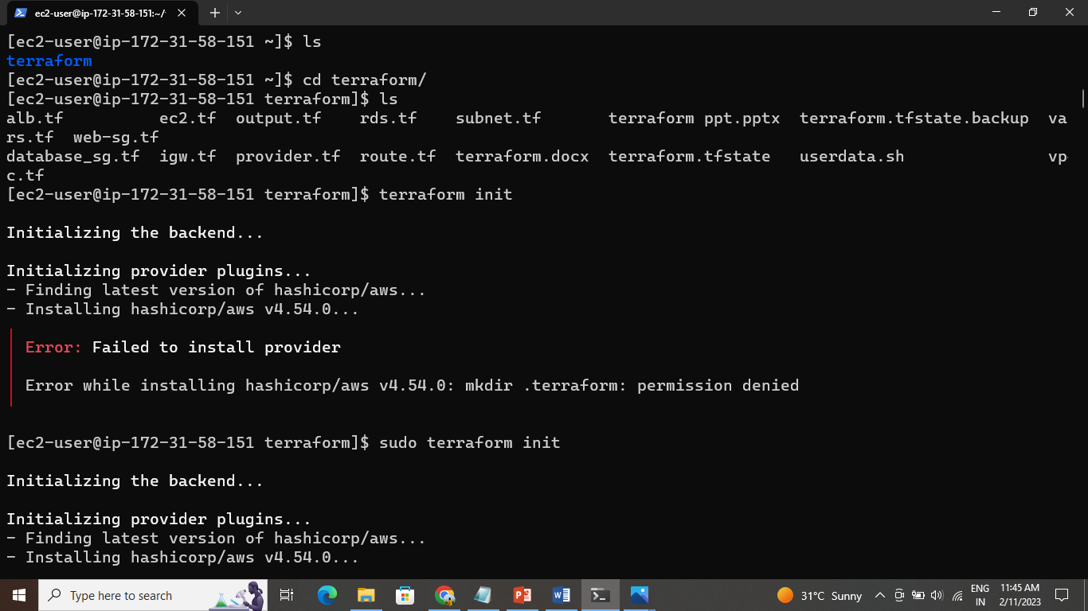

And create a iam user account and give the programmatic access and give the administration access

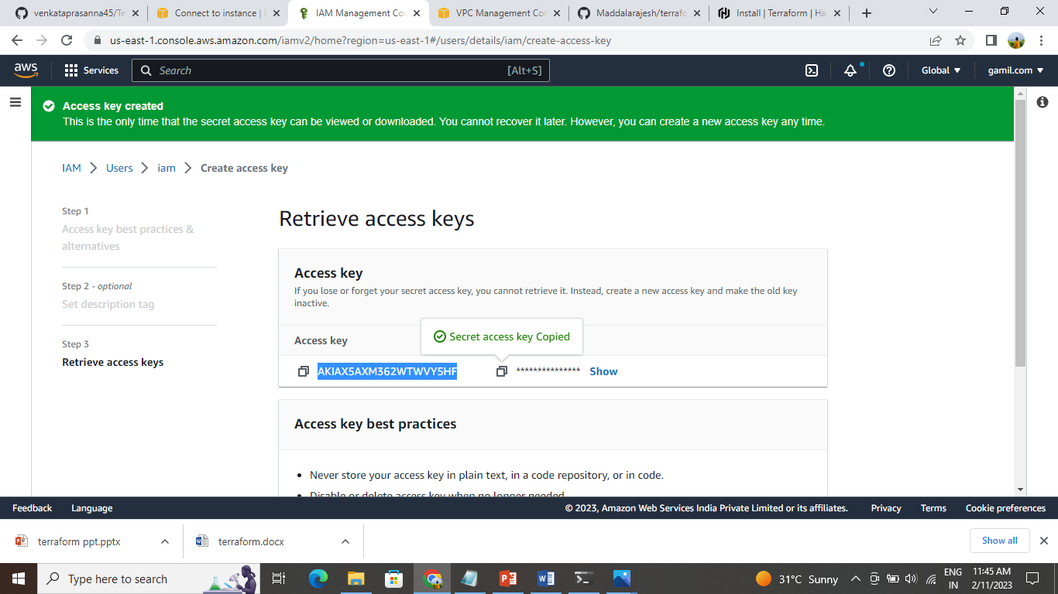

And in terminal create a provider.tf file and give the aws as a provider and give the access key and secret key created in iam

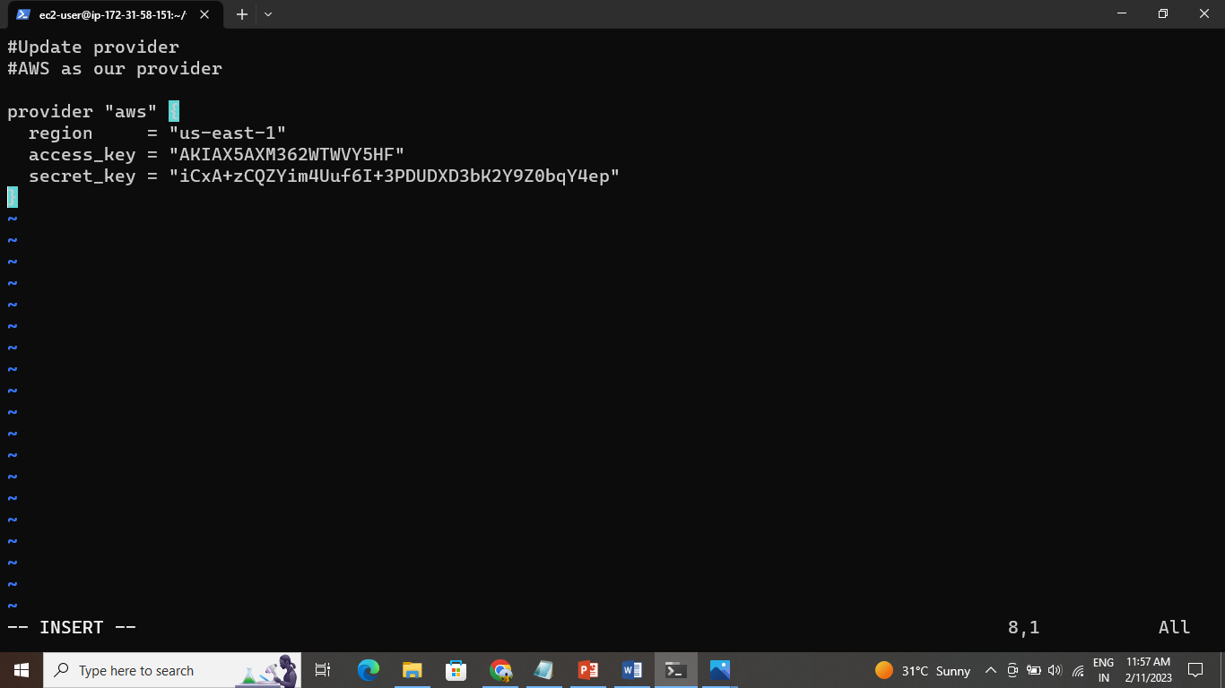

Then initialiaze the terraform and terraform apply

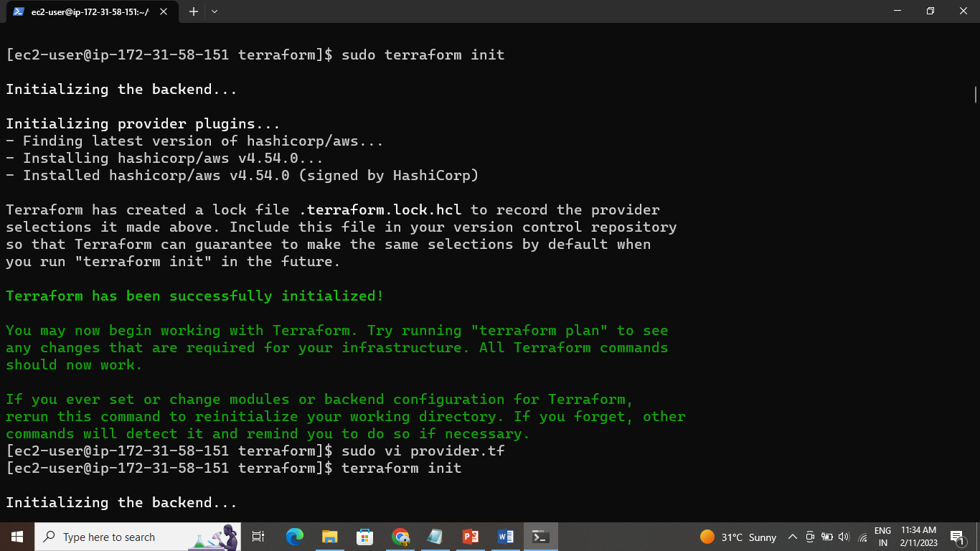

Create vpc.tf file by using the command

Vi vpc.tf

Create a internet gateway and the gateway is connected to the vpc and create file –vi igw.tf

And again initialise the terraform and terraform apply the internet gateway created it is connected to vpc

Create a subnet-vi subnet.tf

Terraform init and terraform apply subnets can be created

Create a route table with the name

Vi route_public_table.tf

Initilaze the terraform and apply whether the script is write or wrong

And it creates the route tables and associate with subnets and the route is connected to internet gateway

Create a security groups –vi web_sg.tf

And again create a security group vi database_sg.tf

Terraform init and apply

Create data.sh file-vi data.sh

And then create the ec2 instance and the give the user data in this instance-vi ec2.tf

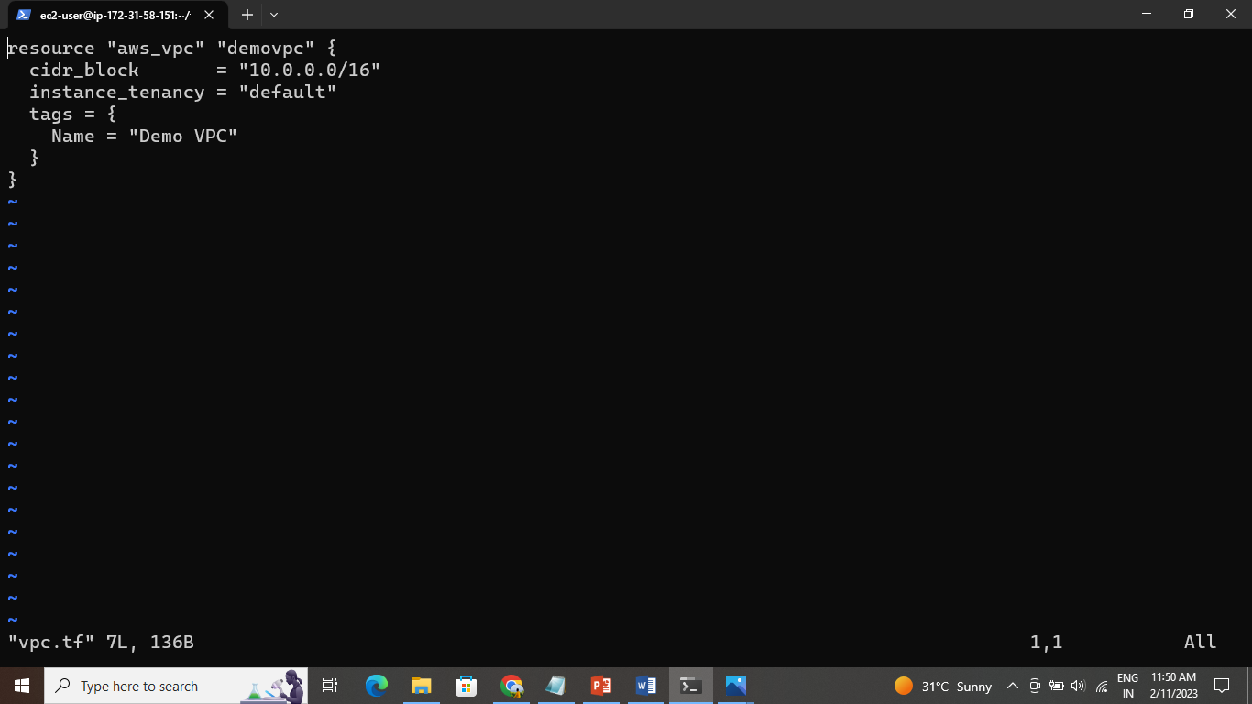

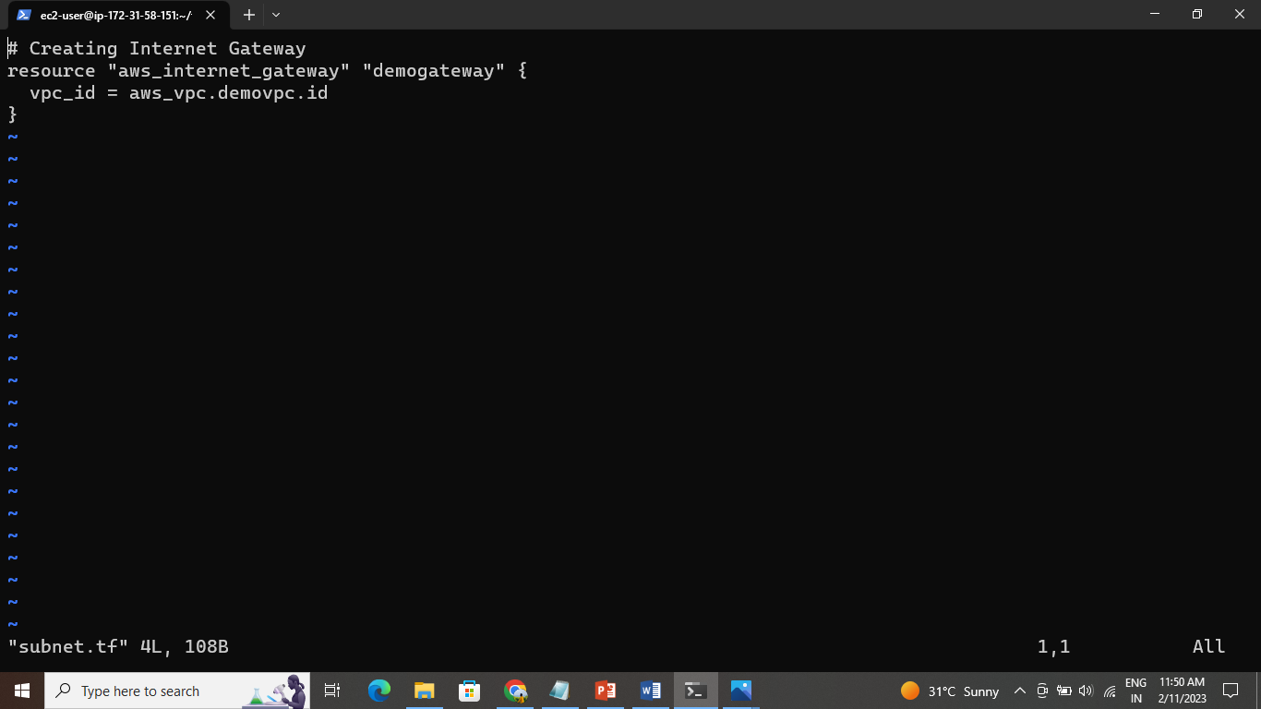

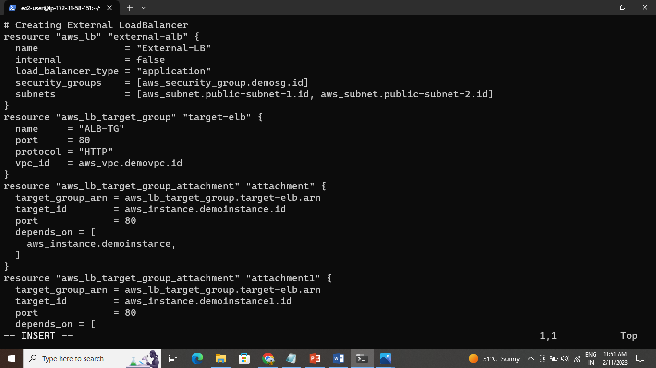

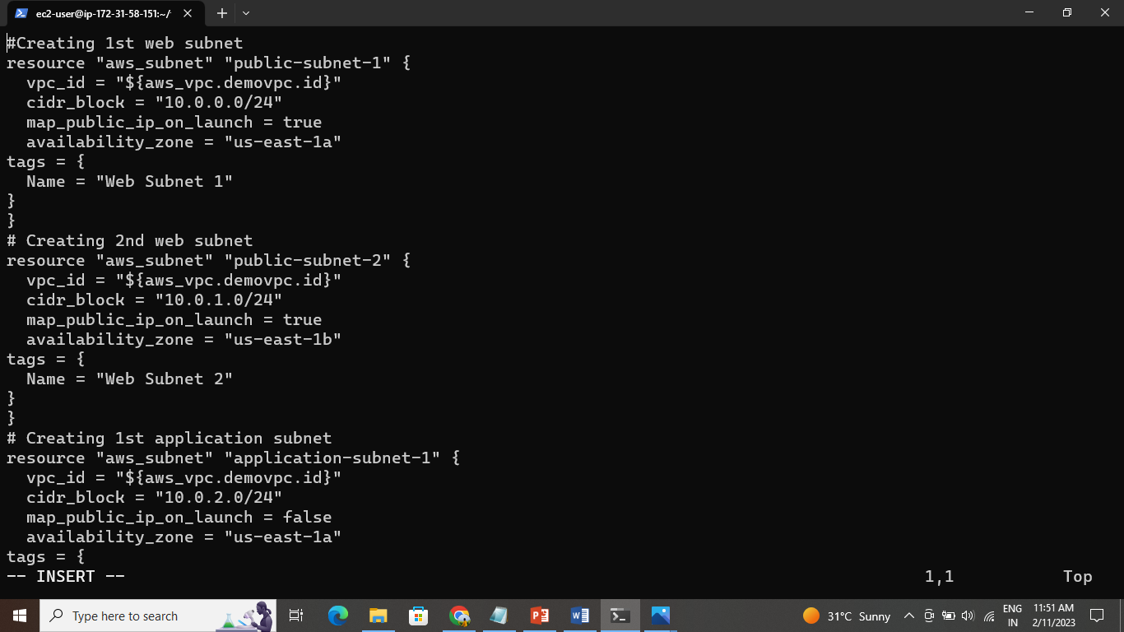

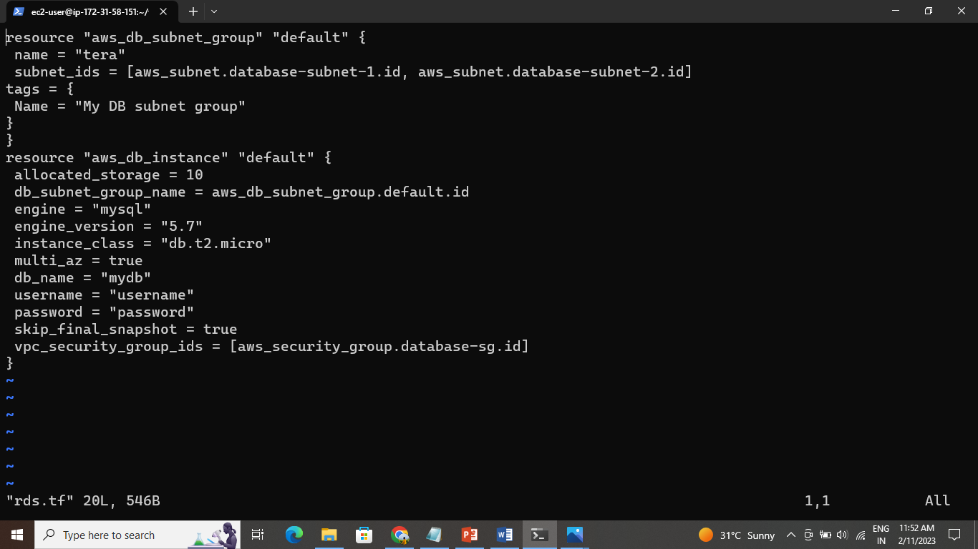

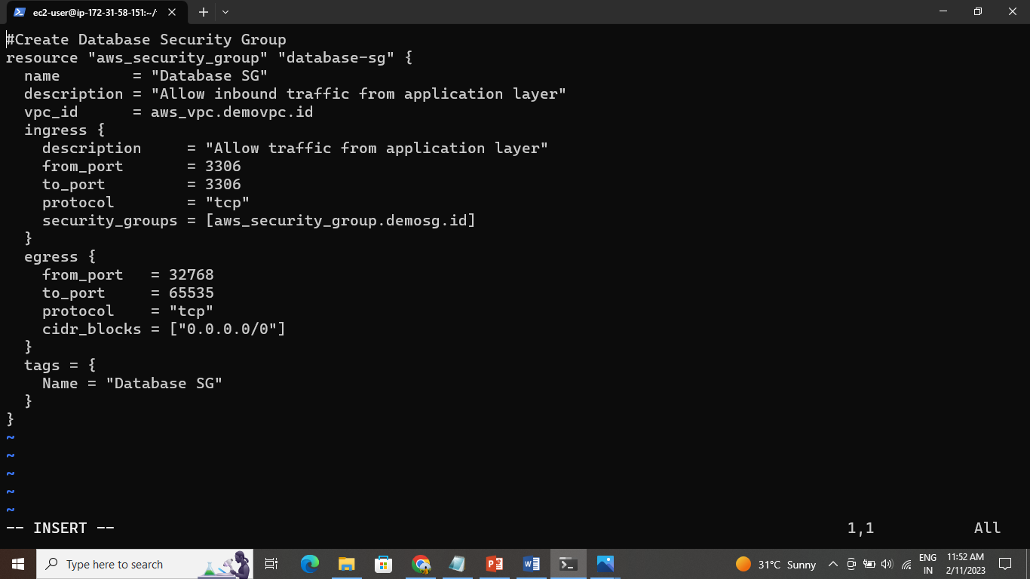

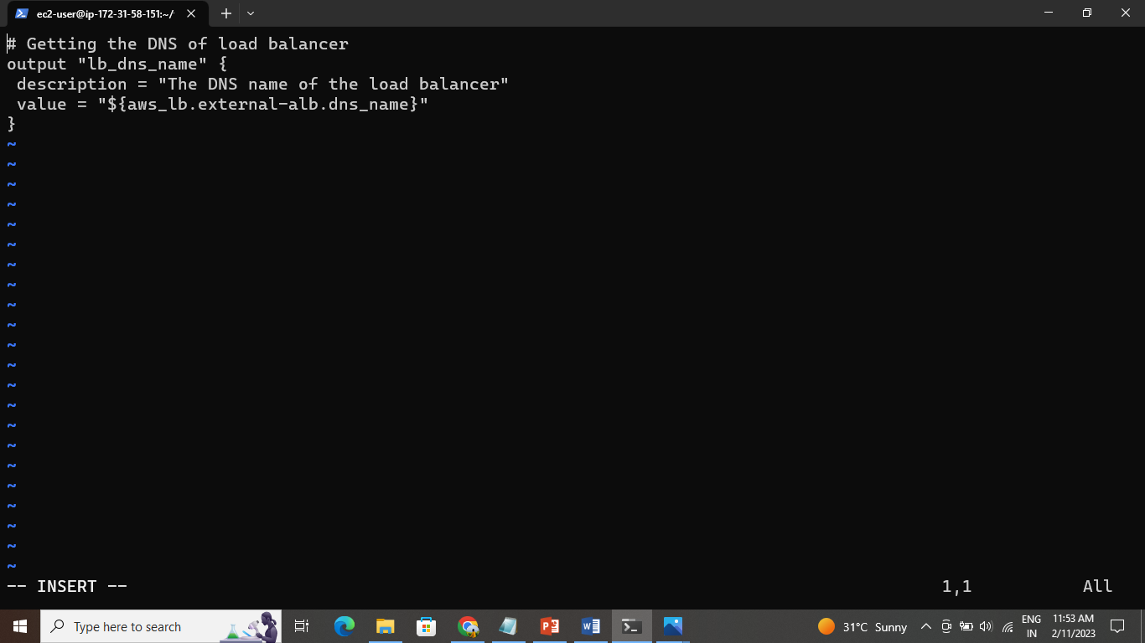

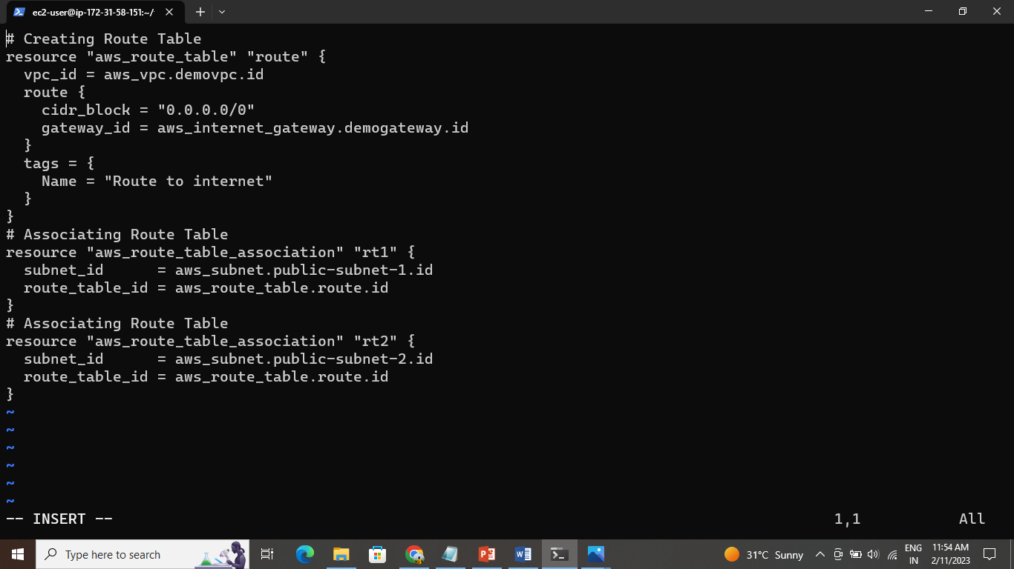

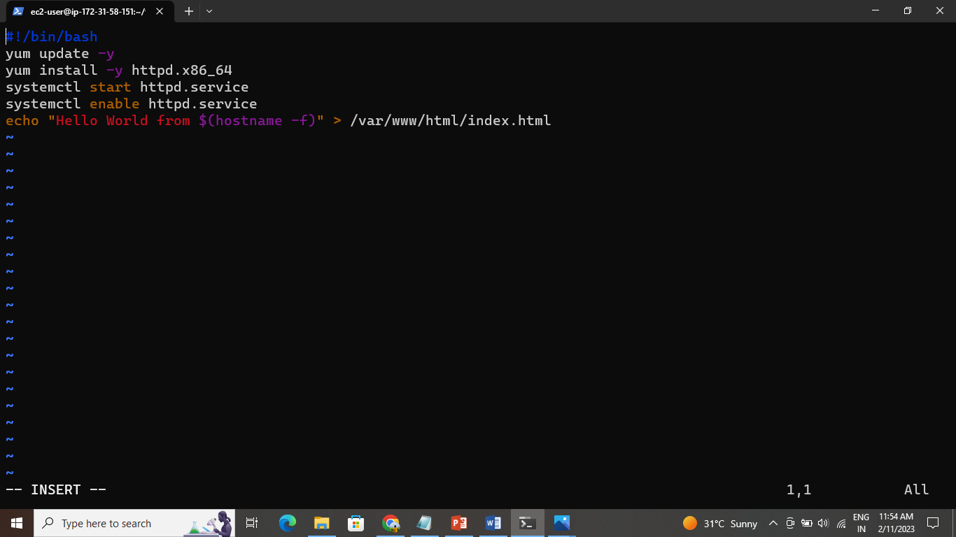

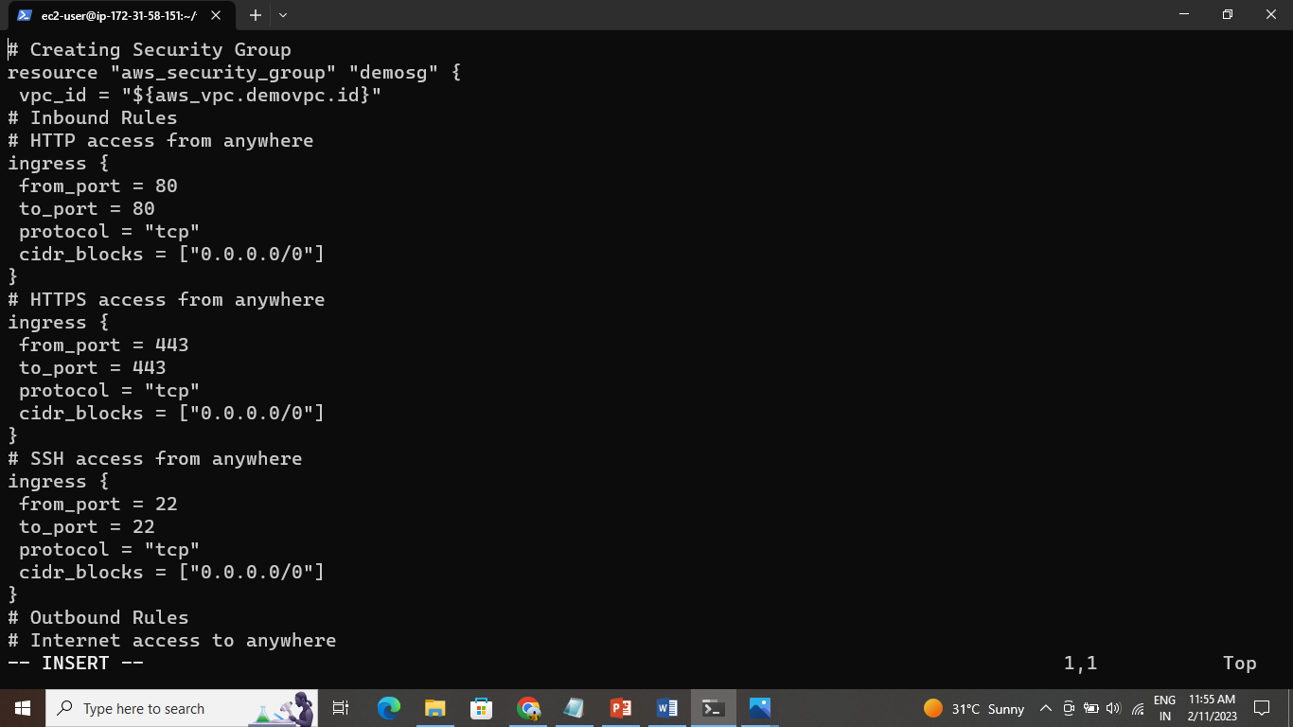

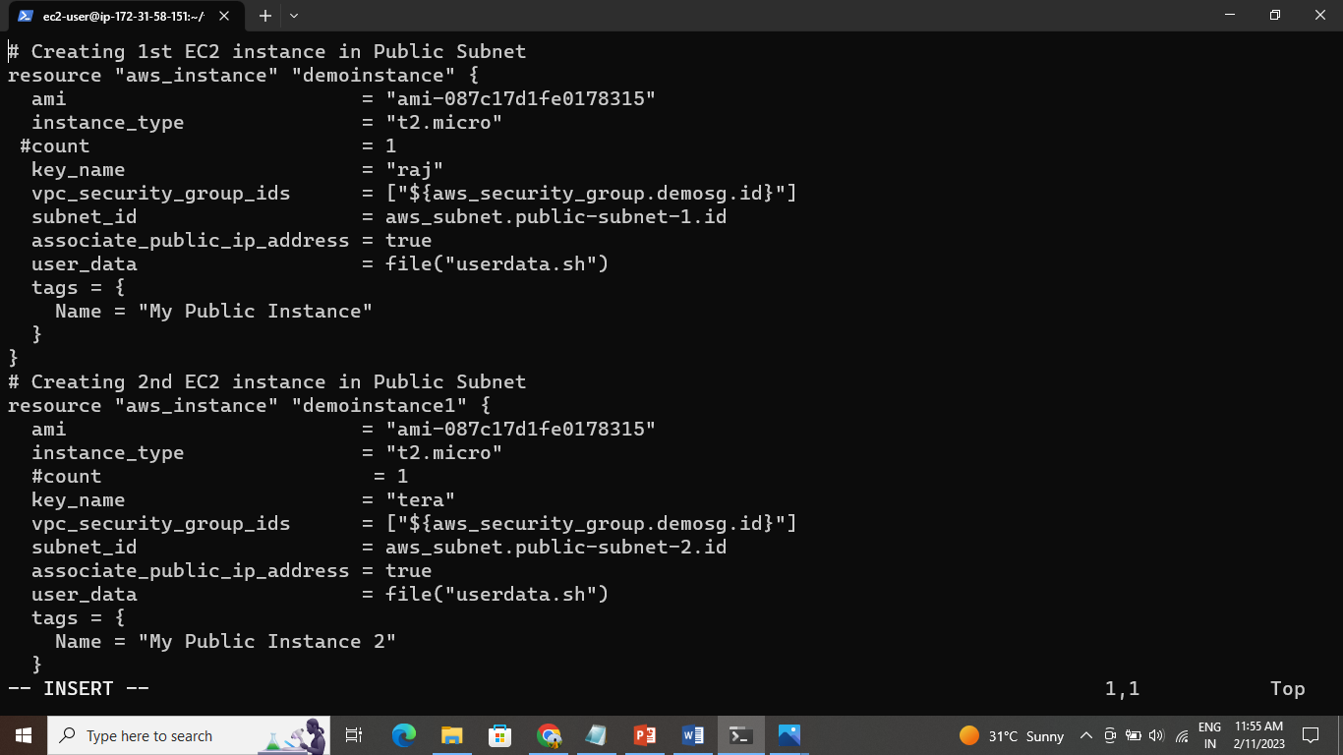

Save the script and init the terraform-terraform init

And terraform apply



